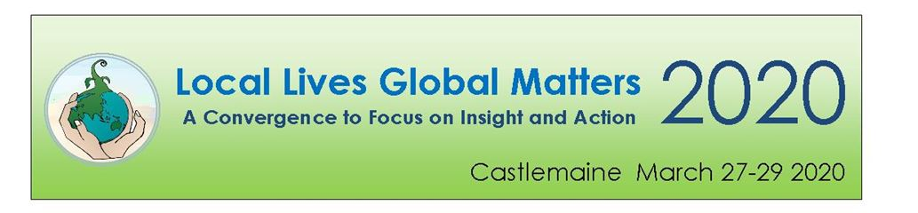
January 21^{st,} 2020
Dear community members and groups,
We invite you to attend and contribute.
We are calling for people, groups and organisations to attend and contribute to ‘Local Lives Global Matters 2020’ in Castlemaine from March 27th to 29th 2020.
The world stands on a precipice and we are facing an extended period of challenge and change. This Convergence is being organized to rekindle and extend the energy generated at the 2015 Local Lives Global Matters Conference. Convergence 2020 will bring together Central Victorian communities in a transformative process to better meet the challenges ahead.
We are living in a world driven by greed, extraction and growth which has brought us to the brink of social, economic and environmental collapse. First Nations People have borne the brunt of this damage. They also hold some of the knowledge of how to nurture and sustain the land we live and work on.
It’s time to make sense of the crises we face; to collaborate and connect; to take deeper, further and faster action; to build resilience and embed deep adaptation; to transform ourselves and our communities; and to support each other as we relinquish what we need to let go of and restore and create what will sustain us.
From Friday afternoon, March 27th until Sunday evening 29th, we envisage community offerings will include conversational group sessions, presentations, workshops, celebrations, performance and more.
Transformative Change
The 2020 Convergence is underpinned by a deep change approach rather than doing ‘more of the same’. We offer the following to provide a framework, and inspire and challenge us in our thinking:
Spirit: What stories do we need to guide us? How do we more deeply connect to the land and each other?
Heart: What do I need to let go of or strengthen? What are we grieving and what are we thankful for?
Head: What is the latest knowledge? How do we make sense of the crisis we face? What do we need to un-learn?
Hands: Where do I put my energies now and with whom? What can we restore and what do we need to create?
Self organising
The 2020 Convergence will be self-organising – the framework and venues will be provided and we’re asking the community to contribute talents and knowledge to make it happen. That could include: curiosity and provocative questions; facilitation of a conversation; running a workshop; food; song and dance; flowers; knowledge; skills etc.
Your contribution to sessions
You or your group are invited to submit a session idea. The organising collective will create a cohesive and diverse program out of proposed sessions.
With a focus on insight and action participants will come away from the 2020 Convergence with clarity on where we are now and what we can each do.
Please contact Natalie Moxham 0448 372 466 or Laurel Freeland 0498 066 660 if you would like to discuss your contribution further.
Please outline your ideas on the Session Proposal Form attached or contact us for a copy. Closing date for submissions is February 19 2020. Late applications may be considered.

Yours sincerely,

John Terry for the 2020 Convergence committee
Phone: 0432 593 514
Email: johnterry@gcom.net.au

